

LAB REPORT

|  |
| --- |
| 01 |

CSE416: Web Engineering Lab

Submitted To

Md. Ashraful Islam Talukder

Lecturer

Department of CSE

Daffodil International University

Submitted By

Student ID: 221-15-5606

Student Name: Mahmudul Hasan Piash

Section: 61_D1

Department of CSE

Daffodil International University

Date of Assignment Distribution: 22nd June,2025

Date of Assignment Submission: 22nd June, 2025

|  |  |
| --- | --- |
| Experiment No: 01 | **Experiment Name:** Implement client-side form validation using javascript. |

Obtained Output:

After click from Register Button we can go to Register Page. Where client side validation form is is implemented.

Took input of Name, email, password, confirm password, favorite genre, division, favourite colour & Country Name. I used Validation in:

1. **Name:** Where the name should be at least 3 Characters lonng. (Used .length() to validate)
2. **E-mail:** Here there should be @ in the sentence. (Used .includes() to validate)
3. **Password:** Here the password should have at least 1 special character, 1 Upper case letter, 1 digit & over all 6 charecters. (Used regular expressions: “/[!@#$%^&()*-+]/”, “/[0123456789]/”, “/[A-Z]/” & .length() to validate)
4. **Confirm Password:** compared with pasword. (Using ===)
5. **Favorite genre:** At least two should be selected. (Used list)
6. **Country Name**: It should be of All 3 upper case word. (used regular expression: “/^[A-Z]{3}$/”)

**Proper way**

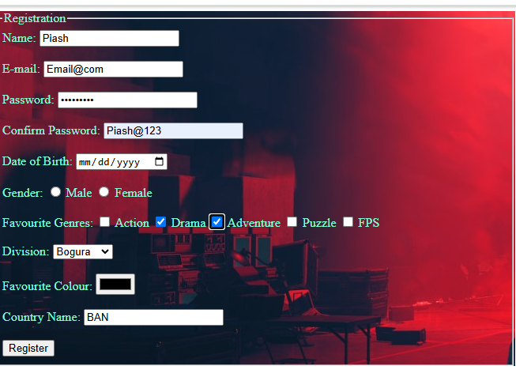

**error**

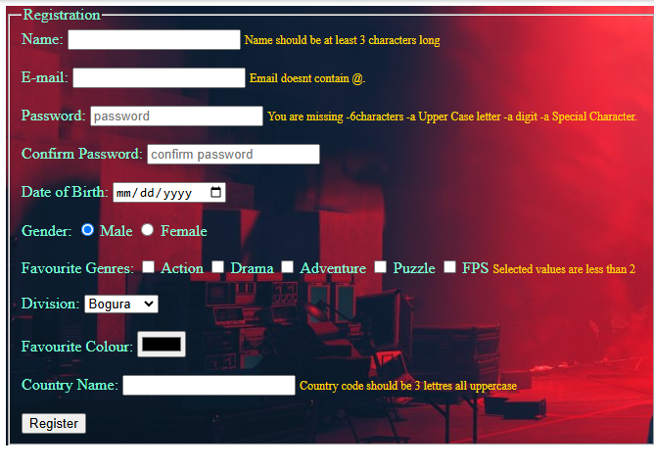

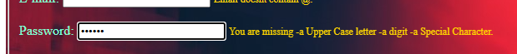

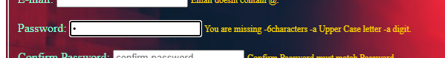



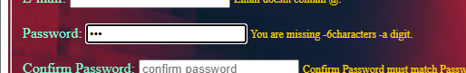

**Regapp.js**

